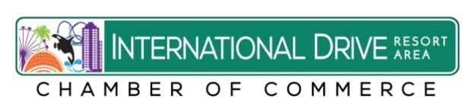
2016 Fact Sheet:

The International Drive Resort Area Represents:
120+ Hotels 40,000+ Hotel Rooms
45% of Hotel Rooms in Orange County
900 Retail Outlets – 5.4 Million square feet - $60 million in Value
342 Restaurants
35 + Attractions
4 Entertainment Complexes
6 Theme Parks including; SeaWorld, Aquatica,
Discovery Cove, Universal Orlando, Islands of Adventure, Wet’nWild
2nd Largest Convention Center in the Country
Employs over 75,000 people
5.4 Million overnight visitors annually
I-Drive area contains: 10.5 Miles – North South Distance
21 Square Miles
7,700 parcels - Valued at $11.5 billion Market Value
Generates $188 million in annual tax revenue
Represents 10 percent of the county’s tax base
120+ hotels with 40,000 + hotel rooms are valued at over $2 billion
The area’s 36 timeshare properties with 7,500 units are valued at $2.6 billion
Source: Orange County Property Appraiser’s Office, I-Drive District and Visit Orlando

