**Celebrating 29 Years of Success!**

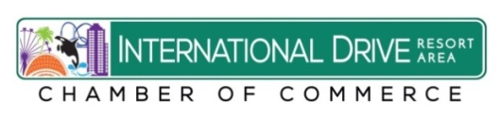

**International Drive Resort Area**

**Chamber of Commerce**

**29th Annual Fall**

**Golf Tournament**

**Friday Sept. 1, 2017**

**Disney’s Palm Golf Club**

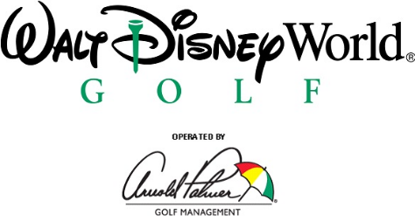

**8:00 a.m. Shotgun!**

**Enjoy a great day of Golf, Barbeque, Beverages, Networking and Door Prizes!**

**Just fill out the attached registration form!**

***Many Thanks to our Sponsors:***



 cid:E2352C3F-CA88-4FF0-9D5B-D9C3B3666AE4

 

**GOLF TOURNAMENT REGISTRATION FORM**

**International Drive Resort Area Chamber of Commerce**

**Friday Sept. 1, 2017– 8:00 a.m. Shotgun!**

**Disney’s Palm Golf Club – 1950 W. Magnolia Palm Dr.**

**Lake Buena Vista, FL**

**Contact name:_________________________________________________**

**Company:____________________________________________________**

**Phone: _________________________Fax:__________________________**

**Email:_______________________________________________________**

**Players Names:**

**1.____________________________________________________________**

**2.__________________________________________________ _________**

**3.____________________________________________________________**

**4.____________________________________________________________**

**Please email your form no later than Aug. 25, 2017 to** [**idracc@earthlink.net**](mailto:idracc@earthlink.net) **or**

**fax your form to 407-217-5719.**

**____________ $ 895.00 Corporate Team Package includes 4 Players & Hole Sponsorship.**

**____________  $ 795.00 Foursome/Four Players**

**____________  Individual Player: $195.00 per golfer**

**_____________Hole Sponsor: $250.00 per hole.**

***Please see attached credit card form for payment. Please make checks payable to:* International Drive Chamber of commerce and mail to: International Drive Resort Area Chamber of Commerce 7557 W. Sand Lake Road #162 Orlando, FL 32819 Phone: 407-903-0084**

**Fax: 407-217-5719** [**idracc@earthlink.net**](mailto:idracc@earthlink.net) **International Drive Resort Area Chamber of Commerce**

**International Drive Resort Area Chamber of Commerce**

**Credit Card Authorization Form**

**Name of Person on Credit Card:**

**_______________________________________________________**

**Company Name:__________________________________________________**

**Type of Credit Card**

***Visa, MasterCard, AMEX Accepted*: ___________________**

**Credit Card Number:________________________________________________**

**Expiration Date of Credit Card:___________________**

**Amount of Charge : $ __________________________**

**To pay for:**

**____ $ 895.00 Corp. Foursome in I-Drive Chamber Sept 1, 2017 Spring Golf Tournament**

**_____ $ 195.00 Player in Sept. 1, 2017 Golf Tournament**

**____$ 250.00 Hole Sponsor at Sept 1, 2017 Golf Tournament**

**Please Print Name:__________________________________________**

**Date:_______________**

**Phone:__________________________ Email:_____________________________**

**Please email back to the Chamber office at** [**idracc@earthlink.net**](mailto:idracc@earthlink.net)

**Or fax to 407-217-5719. Thank you!**