Celebrating 29 Years of Success!
International Drive Resort Area
Chamber of Commerce
29th Annual Spring
Golf Tournament
Friday May 26, 2017
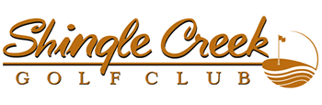

.
8:00 a.m. Shotgun!
Enjoy a great day of Golf, Barbeque, Beverages, Networking and Door Prizes!
Just fill out the attached registration form!
Free Golf Special!
Sign up before April 1st
for the Chamber's 2017 Spring and Fall
Golf Tournaments and Receive a
FREE FOURSOME OF GOLF
to use at your leisure!
See Registration Form for Details!
Many Thanks to our Sponsors:
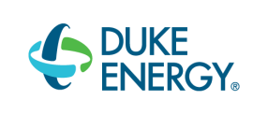
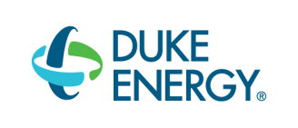

Golf Registration Form
International Drive Resort Area Chamber of Commerce
Friday May 26, 2017– 8:00 a.m. Shotgun!
Shingle Creek Golf Club

Contact name:_________________________________________________

Company:____________________________________________________

Phone: _________________________Fax:__________________________

Email:_______________________________________________________
Players Names:

1.____________________________________________________________

2.__________________________________________________ _________

3.____________________________________________________________

4.____________________________________________________________
Please email your form no later than April 1, 2016 to idracc@earthlink.net or
fax your form to 407-217-5719.

____________ $ 895.00 Corporate Team Package includes 4 Players & Hole Sponsorship.

____________ $ 795.00 Foursome/Four Players

____________ Individual Player: $195.00 per golfer

_____________Hole Sponsor: $250.00 per hole.
Free Golf Special!
____________ Yes! Please sign me up for both the May 26, 2017 Spring
Tournament at Rosen Shingle Creek and the Fall 2017 Chamber Golf Tournament to be held in September 2017 and A FREE FOURSOME of Golf, to be used at your leisure, will be given to those who sign up a corporate foursome for both tournaments by April 1, 2017! Please see attached credit card form for payment. Please make checks payable to: International Drive Chamber of Commerce and mail to: International Drive Resort Area Chamber of Commerce 7557 W. Sand Lake Road #162 Orlando, FL 32819 Phone: 407-903-0084 Fax: 407-217-5719 idracc@earthlink.net
International Drive Resort Area Chamber of Commerce

Credit Card Authorization Form
Name of Person on Credit Card:
_______________________________________________________
Company Name:__________________________________________________
Type of Credit Card
Visa, MasterCard, AMEX Accepted: ___________________
Credit Card Number:________________________________________________
Expiration Date of Credit Card:___________________
Amount of Charge : $ __________________________
To pay for:
_____$ 1,790.00 Special Foursome in 2017 Spring and Fall Golf Tournaments plus extra Foursome
____ $ 895.00 Corp. Foursome in I-Drive Chamber May 26, 2017 Spring Golf Tournament
_____ $ 195.00 Player in May 26, 2017 Golf Tournament
____$ 250.00 Hole Sponsor at May 26, 2017 Golf Tournament

Please Print Name:__________________________________________
Date:_______________
Phone:__________________________ Email:_____________________________
Please email back to the Chamber office at idracc@earthlink.net
Or fax to 407-217-5719. Thank you!

