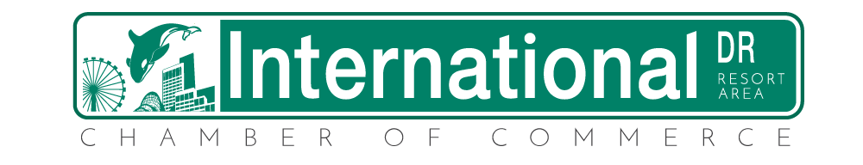

INVOICE

Annual Membership Dues: $495.00

Includes:
- Membership Listing on Chamber Web Site
- Hyperlink on Chamber’s website to your business’s website
- Notifications of monthly luncheons and activities
- Plus all-inclusive Membership Benefit Package

Due Upon Receipt

Please make check payable to:
International Drive Resort Area Chamber of Commerce
Please send check to:
International Drive Resort Area Chamber of Commerce
7557 W. Sand Lake Road #162
Orlando, Florida 32819

