***Celebrating 30 Years of Success!***

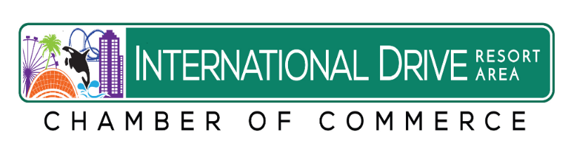

**30th Annual Spring**

**Golf Tournament**

**Friday September 28, 2018**



***.***

**1:30 p.m. Shotgun!**

**Enjoy a great day of Golf, Barbeque, Beverages, Networking and Door Prizes!**

**Just fill out the attached registration form!**

***Many Thanks to our Sponsors:***



 cid:E2352C3F-CA88-4FF0-9D5B-D9C3B3666AE4



**GOLF TOURNAMENT REGISTRATION FORM**

**International Drive Resort Area Chamber of Commerce**

**Friday September 28, 2018– 1:30 p.m. Shotgun!**

**Shingle Creek Golf Club**

**Contact name:_________________________________________________**

**Company:____________________________________________________**

**Phone: ________________________Fax:___________________**

**Email:_______________________________________________________**

**Players Names:**

**1.____________________________________________________________**

**2.__________________________________________________ _________**

**3.____________________________________________________________**

**4.____________________________________________________________**

**Please email your form no later than Sept. 15, 2018 to** [**idraccorlando@**](mailto:idraccorlando@)**gmail.com**

**Or fax your form to 407-217-5719.**

**____________ $ 895.00 Corporate Team Package includes 4 Players & Hole Sponsorship.**

**____________  $ 795.00 Foursome/Four Players**

**____________  Individual Player: $195.00 per golfer**

**_____________Hole Sponsor: $250.00 per hole.**

**International Drive Resort Area Chamber of Commerce**

**Credit Card Authorization Form**

**Name of Person on Credit Card:**

**_______________________________________________________________**

**Company Name:__________________________________________________**

**Type of Credit Card:**

***Visa, MasterCard, AMEX Accepted*: ___________________**

**Credit Card Number:________________________________________________**

**Expiration Date of Credit Card:___________________**

**Amount of Charge : $ __________________________**

**To pay for:**

**______ $ 895.00 Corp. Foursome in I-Drive Chamber Sept. 28, 2018 Fall Golf Tournament**

**_______ $ 195.00 Player in Sept 28, 2018 Golf Tournament**

**_______$ 250.00 Hole Sponsor at Sept. 28, 2018 Golf Tournament**

**Please Print Name:__________________________________________**

**Date:____________________**

**Phone:__________________________ Email:_____________________________**

**Please email back to the Chamber office at** [**idraccorlando@**](mailto:idraccorlando@)**gmail.com**

**or fax to 407-217-5719. Thank you!**