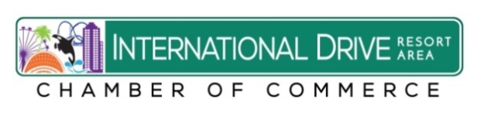
FACT SHEET

The International Drive Resort Area Represents:
150+ Hotels and Resorts
45,000 + Hotel Rooms
900 + Retail Outlets
342 + Restaurants
35 + Attractions
2nd Largest Convention Center in the Country
4 Entertainment Complexes
6 World Class Theme Parks including;
SeaWorld, Aquatica, Discovery Cove, Universal Orlando,
Islands of Adventure, Universal’s Volcano Bay
Contributes to 10% of Orange County Tax Base
Employs 75,000 people
International Drive Resort Area represents 40% of all hotel rooms
in Orange, Osceola and Seminole County

Source: Visit Orlando, Orange County Property Appraiser, I-Drive District

