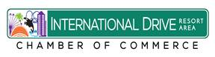

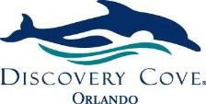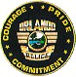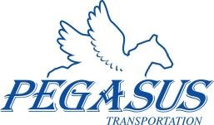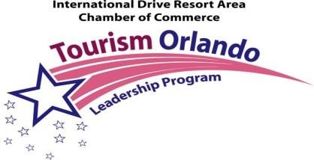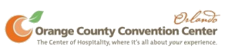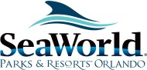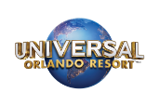

**Tourism Orlando**

**Leadership Program TM**

***Sign Up Today!***

***SPECIAL $995.00 REDUCED Member Rate***

***Just $99 a month on 10-Month Installment Plan!***

"*A unique experience and education in tourism”*

Sponsored by the:

**International Drive Resort Area Chamber of Commerce**

***Mission Statement: “The mission of this program is to create a core of knowledgeable, educated people who based upon this experience will have a unique, in-depth knowledge of the vast components and aspects of the tourism industry.”***

Participants will experience firsthand the vast components and aspects of the tourism industry. Each day will be comprised of unique behind the scenes experiences, special presentations and workshops at the Orange County Convention Center, SeaWorld, Discovery Cove, Aquatica,

Universal Orlando, Walt Disney World, Centerplate, Orlando Health, Dr. P. Phillips Hospital, the Orlando International Airport, Visit Orlando, the Orlando Sentinel, Clear Channel, WFTV Channel 9, the Orlando

Police Department, the Orange County Sheriff’s Office, the UCF Rosen College of Hospitality plus much, much more!

***Participants will:***

* Grow in awareness and understanding of the vast components of the Network and bond with fellow participants through a unique learning experience!
* Acquire your certificate and "PhT" in tourism.
* 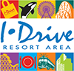Increase your personal knowledge of the tourism industry to

enhance your career opportunities and community leadership.

***How long is the program?***

See the source imageThe program lasts for 10 months and is one day a month from

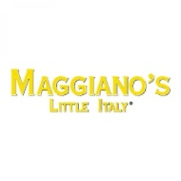8:30 a.m. - 5:00 p.m. The next session will begin Dec. 2020 and run through Sept. 2021. The participants are composed of an accomplished

group of men and women whose backgrounds including management level experience.



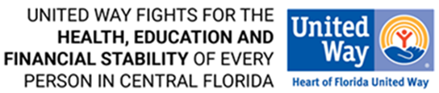

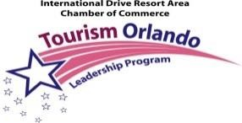**International Drive Resort Area Chamber of Commerce**

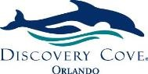

**Tourism Orlando Session 20 Calendar**

# Universal Orlando – December 4, 2020 You will experience behind the scenes, operational aspects and marketing of Universal Orlando one of the most popular theme park destinations in the world! Special presentations and tours will educate and allow you to experience this world class destination in a new light!

# Law Enforcement &Tourism- January 2021 Learn the unique aspects of the award winning Orange County Sheriff’s Office and the Orlando Police Department. Tour the O.C.S.O, Communications Center, repel the tower at the O.C.S.O. Range. Experience the tourist sector through the eyes of law enforcement.

# Transportation & Tourism – February 5, 2021

Tour behind the scenes of the Orlando International Airport, one of the largest airports in the world! Learn proposed transportation plans as well as existing service including Lynx Transportation.

# OCCC and Visit Orlando– March 2021 Tour the OCCC, the

Visit Orlando. Learn how Orlando’s official sales and marketing organization brands, markets and sells the area globally as the premier leisure and convention destination.

# [I-Ride Trolley](https://www.internationaldriveorlando.com/iride-trolley/)Sports and Tourism- April 2021

Learn how sports in the community relates to tourism. Enjoy a day hosted by the Orlando Magic! Special presentations and tours of the RDV Sports complex, Marketing the Magic, Operations plus enjoy a Magic game that night!

# SeaWorld – May 2021

Experience exciting behind the scenes park tours at SeaWorld, Aquatica and Discovery Cove! You’ll Shadow trainers and animal care professionals. Plus! Get the backstage scoop on everything from park Operations to Marketing from SeaWorld Parks and Entertainment department specialists!

See the source image**Healthcare and Tourism – June 2021:** Learn the intricate part the healthcare system plays in the tourism industry. Tour Dr. P. Phillips Hospital and the ORMC medical facility downtown. Explore the many facets of healthcare and learn what happens when a tourist finds himself in need of care.

**UCF Rosen College/Orange County Government- July 2021** Experience a special tour/presentation a the UCF Rosen College of Hospitality. Tour this unique campus and learn from the educators. Plus! Special presentations from Orange County Govt., Code, Fire Dept. and the I-Ride Trolley/I-Drive District and giving back through the United Way.

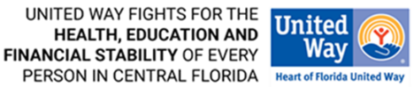**Media Day- August 2021 -** Learn how the media works from the experts. Special presentations and behind the scene tours at the Orlando Sentinel, Clear Channel and Channel 9 studios.

**Walt Disney World Graduation Day – Sept. 2021** Enjoy a [ve](http://disneyworld.disney.go.com/)ry special day at Walt Disney World! Tours, presentations, graduation exercise [an](http://disneyworld.disney.go.com/)d plaque presentations at WDW Resort with special WDW guest speaker!

**International Drive Resort Area Chamber of Commerce**

**Tourism Orlando Leadership Program**

**Admission Application**

***Just $99 a month on 10- Month Installment Plan!***

**To apply for Tourism Orlando please complete the following registration form and email to the Chamber office at**

[**info@internationaldrivechamber.com**](mailto:info@internationaldrivechamber.com) **later than Nov. 1, 2020. Applications are on a first come first serve basis.**

**Space limited. Sign up today!**

**Name:_______________________________________**

**Employer:____________________________________**

**Address: _____________________________________**

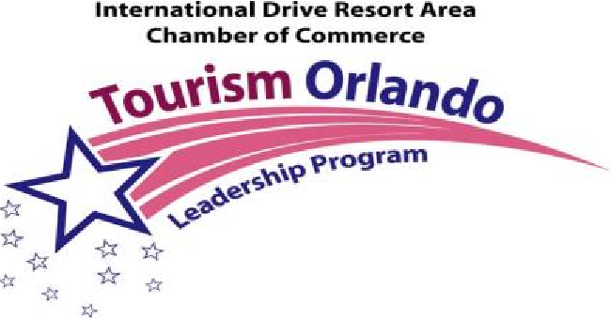**Phone: ____________________Fax:_______________**

**Email:_______________________________________**

**Applicant Commitment:**

**I have cleared my calendar on the appropriate dates. If I am selected to participate I will attend at least 8 of the 10 classes to complete the program.**

**Signature:____________________________________**

**Please check one:**

# ~~_______$ 1,290.00 Member Rate /~~ $199.00 Application Fee

**SPECIAL $995.00 Member Rate**

**_______*Please bill me $99.00 a month on 10-Month Installment Plan***

***_______or Please bill me $50.00 a month on 19- Month Installment Plan***

**_______ $ 1,995.00 / Non Member Rate**

**International Drive Resort Area Chamber of Commerce**

**7557 W. Sand Lake Road #162 Orlando, FL 32819**

**Email:**

[**info@internationaldrivechamber.com**](mailto:info@internationaldrivechamber.com)

[**www.internationaldrivechambe**](http://www.internationaldrivechambe)**r.com**

**Phone: 407-903-0084 Fax: 407-217-5719**

**International Drive Resort Area Chamber of Commerce.**

**Celebrating 32 Years!**

**International Drive Resort Area Chamber of Commerce**

**7557 W. Sand Lake Road #162**

**Orlando, FL 32819**

**Phone: 407-903-0084 Fax: 407-217-5719**

# Email: [info@internationaldrivechamber.com](mailto:info@internationaldrivechamber.com)

# Credit Card Authorization Form

**Name of Person on Credit Card:**

**________________________________________________**

**Company/ Agency**

**Name:__________________________________________________**

**Type of Credit Card**

***Visa, MasterCard, AMEX Accepted*:_______________________________**

**Credit Card Number: _____________________________________________________**

**Expiration Date of Credit Card:____________**

**Security Code: (3 digit code on back of card .)____________**

**Amount of Charge :**

**~~Tourism Orlando Participant - $1,290.00 per participant/~~ plus $199.00application fee. Special $995.00 Membership Rate**

**I-Drive Chamber Tourism Orlando Leadership Program Session 20.**

**Please check one:**

**_____Please charge my card in full $~~1,290.00 participant fee~~**

**Plus $199.00 Application Fee~~.~~ Special $995 Membership Rate**

**______Please bill me 10- month installment plan: $99.00 a month for 10 months-**

**______Please bill me 19-month installment plan: $50.00 per month for 19 months.**

**Please Print Name:__________________________________________**

**Signature:_________________________________________________**

**Date: _____________________________________**

**Phone:____________________________________**

**Email:____________________________________**

**Please email back to the Chamber office at** [**info@internationaldrivechamber.com**](mailto:info@internationaldrivechamber.com)

**or fax to 407-217-5719. Thank You!**